H.T No
Regulations:
A20

Sreenidhi Institute of Science and Technology
(An Autonomous Institution)
Code No:8B730 Date:18-01-2025 (FN)

B.Tech IV-Year I-Semester External Examination, January-2025 (Regular and Supplementary)
FINITE ELEMENT METHODS (MECH)

Time: 3 Hours Max.Marks:70

Note: a) No additional answer sheets will be provided.
b) All sub-parts of a question must be answered at one place only, otherwise it will not be valued.
c) Missing data can be assumed suitably.

Bloom's Cognitive Levels of Learning (BCLL)

Remember | L1 | Apply | L3 | Evaluate | L5
Understand | L2 | Analyze | L4 | Create | L6

Part - A Max.Marks:20
Answer all QUESTIONS

 |  | BCLL | CO(s) | Marks
1 | What is the basic principle of Rayleigh-Ritz method | L2 | CO1 | [2M]
2 | write the shape functions of one dimensional bar element with two nodes | L1 | CO2 | [2M]
3 | Draw a neat sketch of beam element by specifying the degrees of freedom | L1 | CO3 | [2M]
4 | Write the shape functions of CST element | L1 | CO4 | [2M]
5 | What is the basic principle of Galerkin’s approach | L2 | CO5 | [2M]
6 | What is the difference between lumped mass and consistent mass | L2 | CO6 | [2M]
7 | List any four applications of FEM | L1 | CO1 | [2M]
8 | Draw the neat sketch of CST element by specifying the degrees of freedom at each node | L1 | CO4 | [2M]
9 | Write the Governing equation for one- Dimensional Heat Conduction | L1 | CO5 | [2M]
10 | List any two properties of Eigenvectors | L2 | CO6 | [2M]
Part – B Max.Marks:50
ANSWER ANY FIVE QUESTIONS. EACH QUESTION CARRIES 10 MARKS.

 |  |  | BCLL | CO(s) | Marks
11. | a) | What is meant by discretization of a structure? Discuss the various aspects to be considered while discretizing a structure for finite element analysis | L2 | CO1 | [5M]
 | b) | Describe the step-by-step procedure involved in FEM. | L3 | CO1 | [5M]
12. |  | Determine the nodal displacements and support reactions for the bar as shown in fig. Take E=200GPa  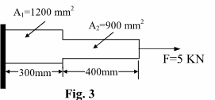 | L1 | CO2 | [10M]
13. |  | For the beam and loading shown in figure determine :  (i) slope at the free end of a beam  (ii) vertical deflection at the midpoint of the uniformly distributed load  Take E=200GPa, I=4 x 10⁶ mm⁴  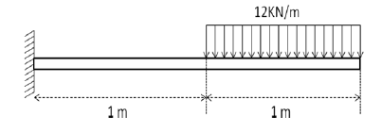 | L3 | CO3 | [10M]
14. |  | Calculate displacements and stress in a triangular plate shown below, fixed along one edge and subjected to concentrated load at its free end. Assume E = 70,000 MPa, t = 10 mm and ʋ = 0.3.  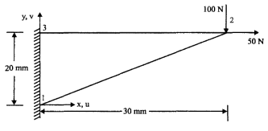 | L3 | CO4 | [10M]
15. |  | A composite slab consists of 3 materials of different conductivities i.e. 22 W/m K, 32 W/m K, 52 W/m K of thickness 0.31 m, 0.14 m and 0.14 m, respectively. The outer surface is 22ºC and the inner surface is exposed to the convective heat transfer coefficient of 28 W/m² K, 800º C. Determine the temperature distribution within the wall. | L3 | CO5 | [10M]
16. |  | Determine the Eigen values and natural frequencies for the stepped bar as shown in figure., Specific weight = 785N/m³ E = 210 GPa  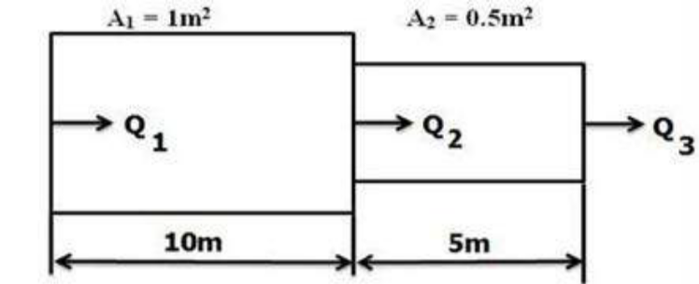 | L3 | CO6 | [10M]
17. | a) | State and explain the principle of minimum potential energy. | L1 | CO1 | [4M]
 | b) | Explain in detail the finite element modelling of one – dimensional problem. | L2 | CO2 | [3M]
 | c) | Write the shape functions of beam element and plot them | L1 | CO3 | [3M]
18. | a) | Explain about shape functions of CST element? | L2 | CO4 | [4M]
 | b) | What is Thermal conductivity matrix for 1D heat transfer problems? | L1 | CO5 | [3M]
 | c) | Write a short note on Dynamic Analysis and its applications in engineering problems. | L2 | CO6 | [3M]
-- 00 -- 00 –

